1. Generated (data from tree;1)

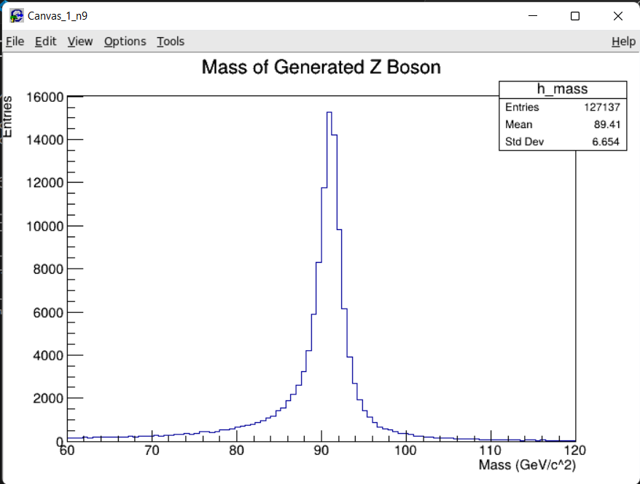

1. Reconstructed (data from tree;2)

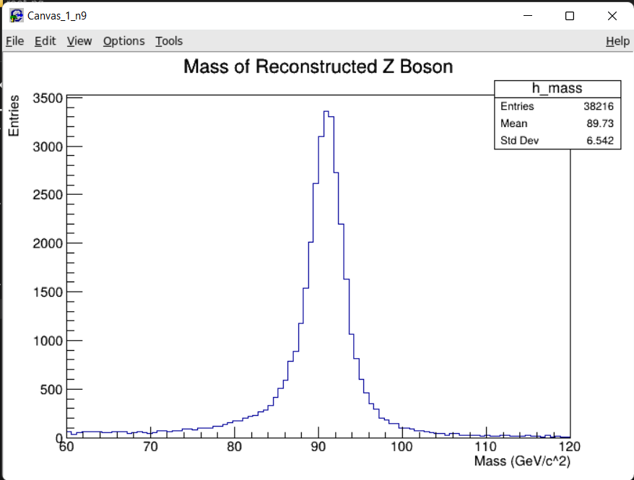

1. Reconstructed using 4 Vectors (tree;2)

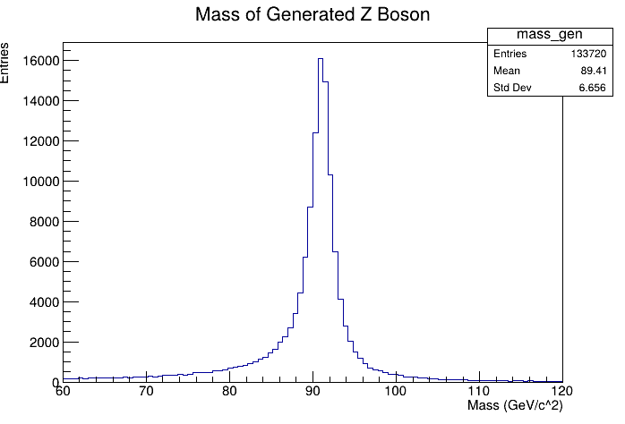

Generated Z Boson using 4 Vectors (tree;2)

